**<< POINT OF SALE SYSTEM>>**

**<< THE QUADS>>**

**AMIT PATHAK**

**JENITA KAWAN**

**SAMIKSHYA LUITEL**

**UMANGA MULMI**

**SOFTWARE DESIGN DOCUMENT**

**Version 1.0**

**INDEX**

TITLE Page No.

1. Introduction 1
2. Overview of architecture 2
3. Use cases 3
   1. Use case diagram
   2. Use case specifications
      1. UC01- Update inventory
      2. UC02- Generate sales report
      3. UC03- Check price
      4. UC04- Shift Clock-in
      5. UC05- Make a sale
      6. UC06- Register cashier
4. Classes and their interactions 4
   1. Class diagram
   2. Details of classes
      1. Cl – Cashier
      2. C2 – Sales transactions
      3. C3- Manager
      4. C4- Inventory
      5. C5- Administration
      6. C6- Payments
   3. Sequence diagrams
      1. SQ1- Update inventory in POS system
      2. SQ2 -Generate sales report
      3. SQ3- Make a sale
      4. SQ4 -Employee Login
      5. SQ5 -Employee clock in
5. State transition diagram 5
6. User interface design 6
   1. Sample screen 1 – Main Dashboard
   2. Sample screen 2 – Employee Clock-in/Clock-out
   3. Sample screen 3 – Cash Register
   4. Sample screen 4- Administrator Control
7. Conclusion 7

1. Introduction

This design document is about a web application “Point of Sale “. This application simply works as a cash register with multiple screens. Employee can login in the system using various assigned pin. Once the employee is logged into the system, the employee can do respective work as they are design to operate the store. The program would help the store management run the store smoothly with proper tracking of the system with the help of the software. The software would able to track, implement and report the inventory to the administration. The software will also be able to track sales, report monthly report of sales and purchases. The system will be able to compete all the vital information and keep track of all the sales and purchases. The design in software engineering is important since it helps to track all the work progress of the application. The design increases the efficiency and productivity as it provides proper guidance. It makes easier to code with the details of required specifications.

The design document is divided into different sections in order to understand the project in a better way. The first section (Section 1) is Introduction which gives a brief overview about our project as well the design document. The second part (Section 2) is Overview of architecture. It will explain about the architecture style we have used for the connections in the program. A diagram will be attached in this section which represents the architecture style we will be using. The third section (Section 3) will explain about the Use cases, and this section will have two sub sections namely a) use case diagram and b) use case specifications. Along with the use case diagram for the application, all the required use case specification will be included in this section. Class diagrams is in the fourth section (Section 4) of this document. It is divided into three subsections and they are class diagram, details of classes and sequence diagrams. It will include a class diagram for the web application as well as the details of the classes and their attributes from the class diagram. The sub section with sequence diagram will include five different sequence diagrams related with the primary use cases. The section 5 is state transition diagram which will include a state transition diagram. It will also have a brief description about the different states in the application. The sixth section (Section 6) is the user interface design. This section will have the multiple display snapshots. These display snapshots will give visual representation to the web application. A brief description about the related display snapshot will be provided in this section. The section 7 is Conclusion and it will include the summary of learning from the design document.

1. Overview of architecture

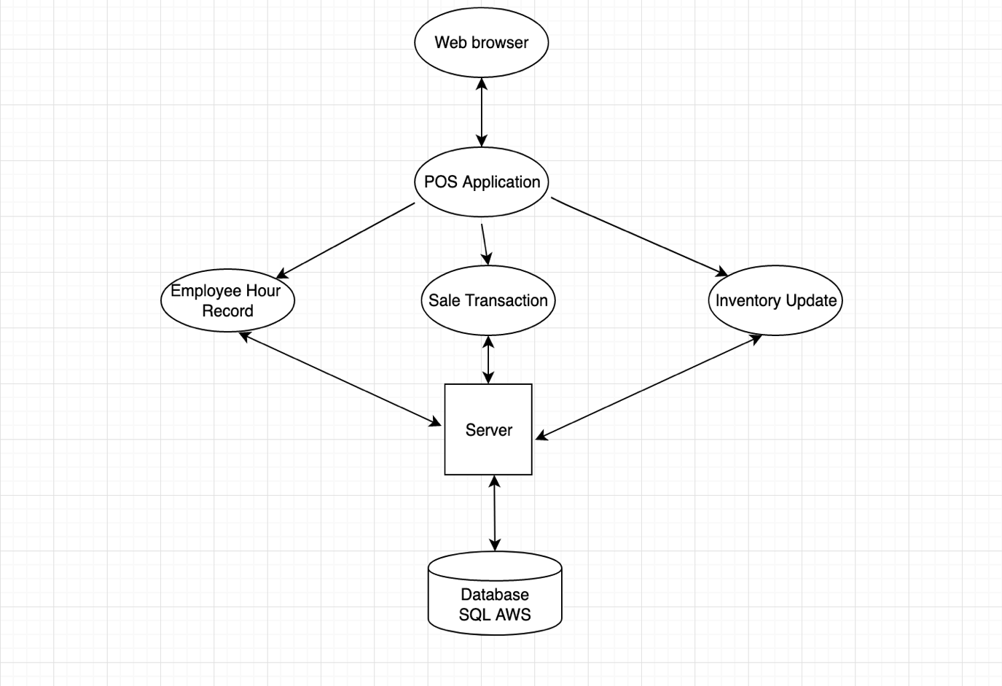

Fig 1: Client- Server Architecture of POS system

We use client-server architecture for our point of sale system because it is a web application and it uses both client and server to perform its all major functionalities. This architecture fits our web application system because it performs certain functionalities on client system itself and other using the server and database. The employee hours, items in inventory and sales report all go thought the server and saved in our database. The sale transaction and calculation are performed in the client machine and its report is saved in the database. The web application will be hosted in a cloud server and the reports are stored in a central cloud database for easy and fast retrieval. The client-server system also provides remote access to the application at any time so Client- Server model will be best for our web application.

3. Use cases

1. Use case diagram

Fig 2: Use Case Diagram

1. Use Case Specifications:

i. UC1 – Update inventory

|  |  |
| --- | --- |
| Use Case Number: | UC-01 |
| Use Case Name: | Update inventory |
| Overview: | Administrator updates the inventory (i.e. adds new item to the inventory list and delete items that are no longer used) |
| Type: | Primary |
| Actors: | Administrator |
| Pre-condition: | Administrator has selected update inventory option. |
| Main Flow: | 1. Administrator logs in the system with his pin. 2. Administrator chooses the option to update inventory. |
| Alternate flow: | None |
| Post-condition: | True |
| Cross-reference: | Administrator’s pin should be verified. |

ii. UC2- Generate sales report

|  |  |
| --- | --- |
| Use Case Number: | UC-02 |
| Use Case Name: | Generate sales report |
| Overview: | Manager generates sales report for a specific period of time (i.e. week, day, month) |
| Type: | Primary |
| Actors: | Manager |
| Pre-condition: | Manager has selected sales report option. |
| Main Flow: | 1. Manager logs in the system with his pin. 2. Manager chooses the option to generate sales report. |
| Alternate flow: | None |
| Post-condition: | True |
| Cross-reference: | Manager’s pin should be verified. |

iii.UC3- Check Price

|  |  |
| --- | --- |
| Use Case Number: | UC-03 |
| Use Case Name: | Check Price |
| Overview: | Customer wants to check price of an item |
| Type: | Primary |
| Actors: | Customer, Cashier |
| Pre-condition: | Manager has selected sales report option. |
| Main Flow: | 1. Customer picks the desired item 2. Customer takes the item to the cashier 3. Cashier search for the item in the system 4. The system returns the item name with its price 5. Cashier says the price of the item to the customer |
| Alternate flow: | 2. If the customer changes the item selection, the use case is restarted. |
| Post-condition: | True |
| Cross-reference: | Change item |

iv. UC4- Shift Clock-in

|  |  |
| --- | --- |
| Use Case Number: | UC-04 |
| Use Case Name: | Shift Clock-in |
| Overview: | Customer wants to check price of an item |
| Type: | Primary |
| Actors: | Manager |
| Pre-condition: | Manager has selected sales clock-in option. |
| Main Flow: | 1. The system asks for pin number 2. The manager enters the pin number. 3. If the pin is valid, the managers clock in/out dashboard is shown with current time 4. The manager selects the In button.   The system shows the In has been recorded with its time |
| Alternate flow: | If the pin number is not correct, the system will ask for the correct pin again |
| Alternate flow: | The manager can exit the clock in/out system anytime, the use case will be restarted again. |
| Post-condition: | True |
| Cross-reference: | Confirm PIN |

v. UC5- Make a sale

|  |  |
| --- | --- |
| Use Case Number: | UC-05 |
| Use Case Name: | Make a sale |
| Overview: | Cashier make the sales by selling items to the customer. |
| Type: | Primary |
| Actors: | Cashier |
| Pre-condition: | Cashier has to clock-in. |
| Main Flow: | 1.Cashier login to the terminal.  2. Cashier looks at the product.  3. Cashier rings the product at the system. 4.Cashier sells the product |
| Alternate flow: | 3.Cashier can cancel the transaction at any time if the customer wishes to do so. They the transaction has to start all over again. |
| Post-condition: | True |
| Cross-reference: | None |

vi. UC6- Register Cashier

|  |  |
| --- | --- |
| Use Case Number: | UC-06 |
| Use Case Name: | Register Cashier |
| Overview: | Admin or Manager registers cashier on the system |
| Type: | Primary |
| Actors: | Manager or Administrator |
| Pre-condition: | Actor has selected register cashier option to start the process |
| Main Flow: | 1. Actor logs in to the system  2. Actor selects register cashier option  3. Actor enters necessary details of cashier  4. Actor selects register button after the details is complete. If any field is missing, the system won’t let actors register the cashier. |
| Alternate flow: | 1. If the actors have not logged in to the system, he cannot register the cashier |
| Alternate flow: | If cashier is already registered, system won’t let them register again |
| Post-condition: | True |
| Cross-reference: | None |

4. Classes and their interaction

* 1. Class diagram

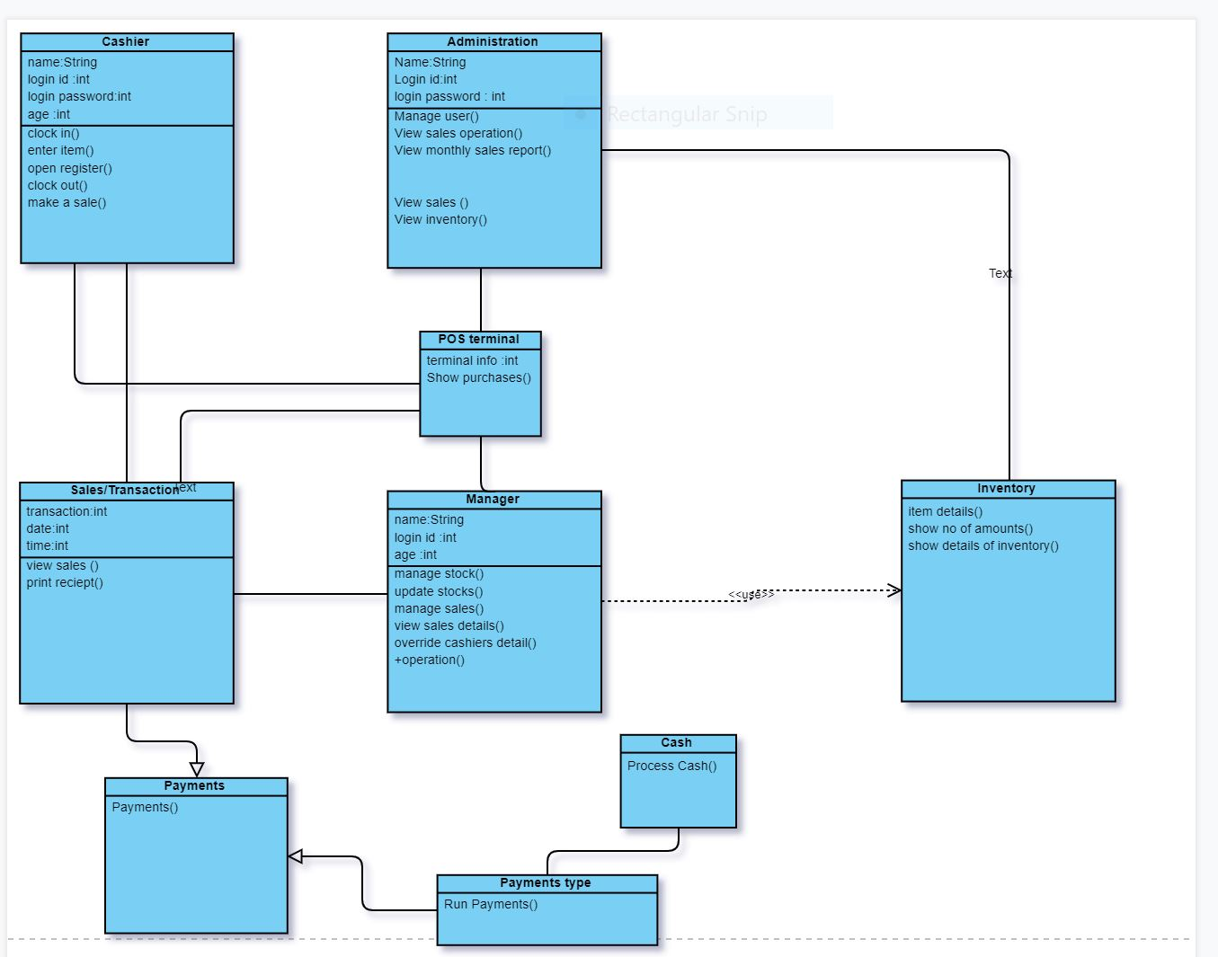

Fig 3: Class diagram of the POS

* 1. Details of classes

In our program the classes are mentioned, and the classes are explained and described as the following:

i. Cashier

Attributes:

|  |  |  |
| --- | --- | --- |
| Attribute name | Type | Description |
| Name | String | A variable used to store the name of a Cashier |
| Login Password | Int | Stores the pin number for login |
| Age | Int | The age of the cashier |

Operations/Methods:

|  |  |  |  |
| --- | --- | --- | --- |
| Method Name | Arguments passed | Expected return value | Description |
| Clock In /Clock Out | None | String | A function used to retrieve the clock in and out time of the user |
| Enter item | String | Price from the inventory | A function used to ring the item for the purpose of the sale |
| Open Register | None | None | Opens the register for different use purposes |
| Make a sale | String | Total price from the ring of sale | The item price is given, and total cost is shown in the description |

ii. Sales Transaction

Attributes:

|  |  |  |
| --- | --- | --- |
| Attribute name | Type | Description |
| Transaction | Int | A record of the transaction developed |
| Date | Int | Retrieves the date of today for the transaction |
| Time | Int | The time of the transaction |

iii. Operations/Methods:

|  |  |  |  |
| --- | --- | --- | --- |
| Method Name | Arguments passed | Expected return value | Description |
| Print Receipt | None | String | A function used to retrieve the entire transaction |
| Get total | String | Price from the inventory | A function used retrieve the total sale of the transaction |
| View Sales | None | None | Displays all the sales of the transaction with detailed information |
|  |  |  |  |

iv. Manager

Attributes:

|  |  |  |
| --- | --- | --- |
| Attribute name | Type | Description |
| Name | String | A variable used to store the name of a Manager |
| Login Password | Int | Stores the pin number for login |
| Age | Int | The age of the Manager |

Operations/Methods:

|  |  |  |  |
| --- | --- | --- | --- |
| Method Name | Arguments passed | Expected return value | Description |
| Manage Stock | None | String | A function used to balance and check the stock balances. |
| Update Stock | String | Price from the inventory | A function used to update and manage the stock |
| View Sales Details | None | None | Check the details of the sales transaction |
| Override Cashier details | String | Total price from the ring of sale | Manager has the special skills to override operation from the cashier |

v. Inventory

|  |  |  |
| --- | --- | --- |
| Attribute name | Type | Description |
| Name | String | A variable used to store the name of a Manager |
| Login Password | Int | Stores the pin number for login |
| Age | Int | The age of the Manager |

Operations/Methods:

|  |  |  |  |
| --- | --- | --- | --- |
| Method Name | Arguments passed | Expected return value | Description |
| Manage Stock | None | String | A function used to balance and check the stock balances. |
| Update Stock | String | Price from the inventory | A function used to update and manage the stock |
| View Sales Details | None | None | Check the details of the sales transaction |
| Override Cashier details | String | Total price from the ring of sale | Manager has the special skills to override operation from the cashier |

vi. Administration

|  |  |  |
| --- | --- | --- |
| Attribute name | Type | Description |
| Name | String | A variable used to store the name of an Administration |
| Login Password | Int | Stores the pin number for login |
| Age | Int | The age of the Administration |

Operations/Methods:

|  |  |  |  |
| --- | --- | --- | --- |
| Method Name | Arguments passed | Expected return value | Description |
| Manage user | None | String | A function used by manager to check all the system function in the system |
| View Sales Operation | String | Price from the inventory | A function used to update and manage the sales and stocks |
| View Monthly Sales report | None | None | Check the details of the sales transaction |
| View inventory | String | Total price from the ring of sale | Administration has the right to check all the inventory in the system |

vii.Payments

Operations/Methods:

|  |  |  |  |
| --- | --- | --- | --- |
| Method Name | Arguments passed | Expected return value | Description |
| Payments | Type of Payments | Conformation of the Payments | It takes to the next level of the payment for the function |
|  |  |  |  |
|  |  |  |  |
|  |  |  |  |

viii.Cash Payments

|  |  |  |  |
| --- | --- | --- | --- |
| Method Name | Arguments passed | Expected return value | Description |
| Cash Payments | Process the cash payment | Change returned | Takes the cash transaction and returns the needed change in the transaction |
|  |  |  |  |
|  |  |  |  |
|  |  |  |  |

C. Sequence diagrams

Below are the sequence diagrams based on five primary use cases for the POS system.

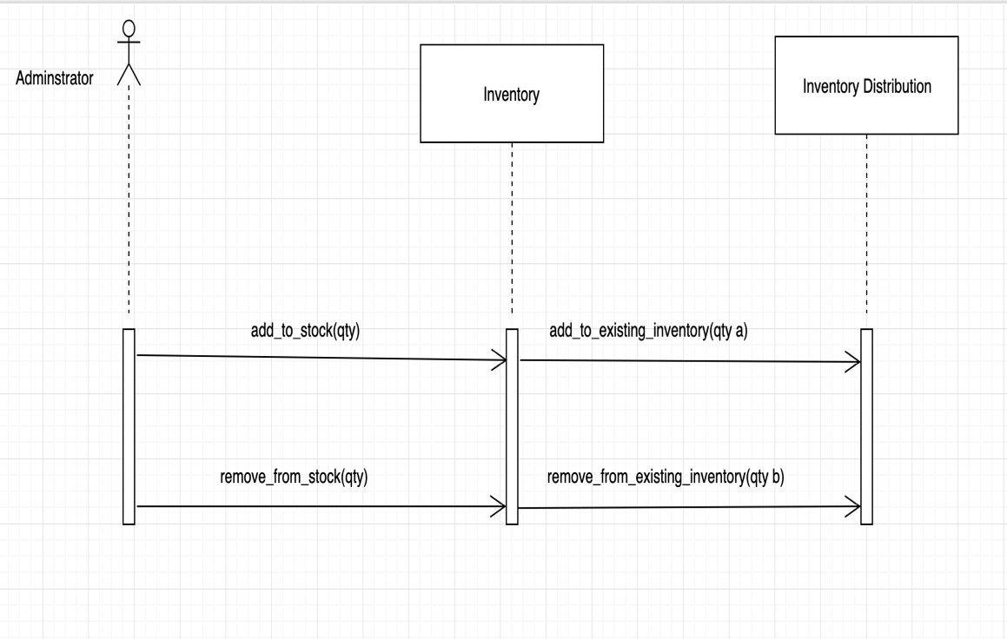

Fig 4: SQ1 Update inventory in POS system

The above figure shows the sequence diagram to update inventory in POS system. The actor is the administrator who is the only person authorized to update inventory. The system administrator can add and remove the required inventories. The administrator can add inventory to the list of existing inventories which makes the sale of that item possible. Also, if there is any inventory which is no longer available then the administrator can permanently remove that inventory from the list of existing inventories.

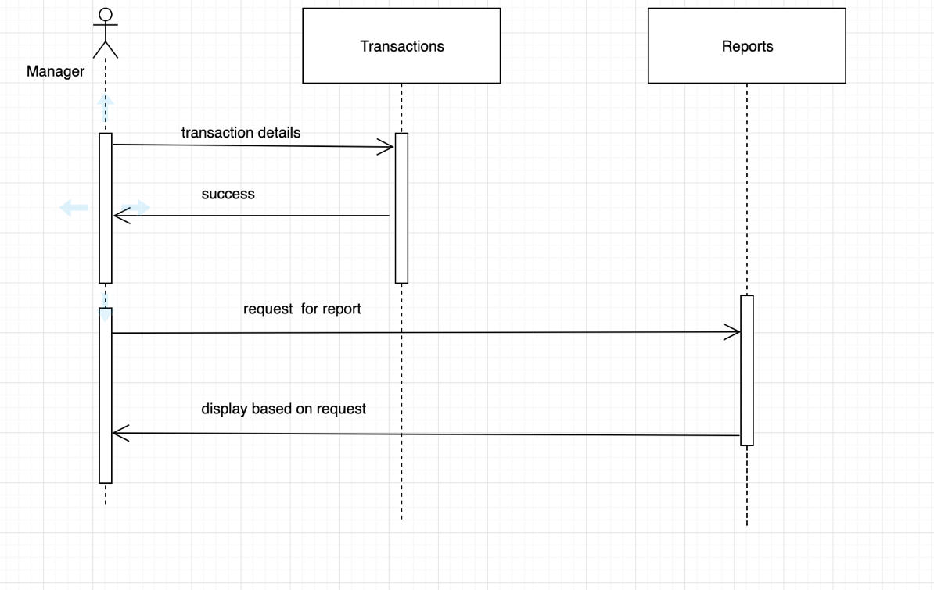

Fig 5: SQ2 Generate sales report

The above figure shows the sequence diagram to generate sales report in the POS system. The manager is the authorized personnel for this activity. All the sales transactions made in the POS system are accessible to the manager. He can view the details of all the transactions made in the POS system. The sales report is based on all the transactions made in the system. The manager can request for the sales report of desired timeframe such as a day, week or a month. The sales report will be displayed based on the request of the manager.

Fig 6: SQ3 Make a sale

The above figure shows the sequence diagram to make a sale in the POS system. In this sequence diagram, two actors Customer and Cashier are involved. Customers selects desired items and brings all the selected items to the counter. Then the cashier tallies all the items in the system along with the cost. He tells the total amount to be paid to the customers and accepts the payment from the customer. Then the amount received from the customer is deposited in the cash register and remaining change is provided to the customer along with the sales receipt.

Fig 7: SQ4 Employee Login

The above figure represents the sequence diagram for the employee login in the POS system. In this diagram, the actors are Administrator, Manager and Cashier. The homepage of the POS system is accessible to all the employees. Once they enter the home page, they can see the “Login” button. When the user presses the Login button, the login page is displayed. The user is then asked to enter the pin for further access. When the user enters the pin, the entered pin is checked with the stored pin for each employee in the database. If the entered pin matches with the pin stored in the database, then the employee is logged in to the POS system. If the pin entered by the employee doesn’t match with the stored pin in the database, then “invalid user” is displayed in the screen.

Fig 8: SQ5 Employee clock in

The above figure represents the state diagram for employee clock in in the POS system. The homepage of the POS system is accessible to all the employees. Once they enter the home page, they can see the “Login” button. When the user presses the Login button, the login page is displayed. The user is then asked to enter the pin for further access. When the user enters the pin, the entered pin is checked with the stored pin for each employee in the database. If the entered pin matches with the pin stored in the database, then the employee is logged in to the POS system. Once the user is logged into the system, he can select “clock in” in the option menu. This will clock in the employee in the system and the employee can further see his clock in hours if he chooses to display his clock in status.

5. State transition diagrams

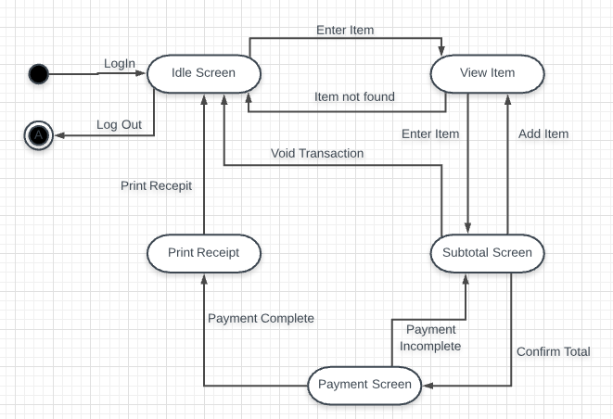

Fig 9: State transition diagram

The state transition diagram starts with login. Then it leads to the idle screen. From this state, the user enters the item. If the item is found, it goes to view item state and if the item is not found, it goes back to idle screen state. After view item state, if user clicks on add item, it will take them to subtotal screen. The user can add the items in this screen.

After the user confirms the total, the program goes to payment screen state. If the payment is completed, the program leads to print receipt state. Otherwise, it will take the user back to subtotal screen again. The user can void the transaction in subtotal screen to go back to idle screen again. The program goes to idle screen state also after the receipt is printed. The program runs until the user logs out.

6. User interface design

A. Screen 1 – Main Dashboard

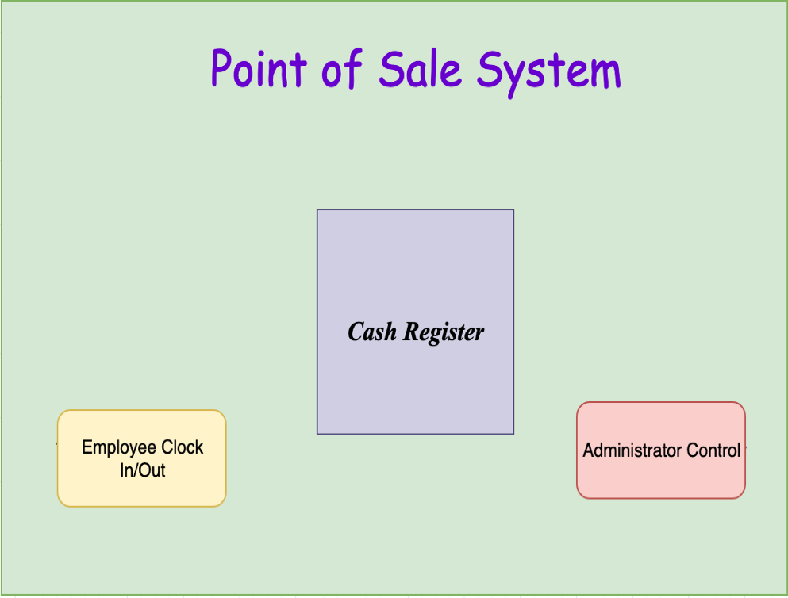

Fig 10: Main Dashboard UI

Screen 1 shown above will be the main dashboard screen user will be able to access when they use the Point of Sale system. There are three functionalities offered from this screen. The Employee Clock In/Out button on the bottom left of the screen will take user to the employee clock in/out functionality screen where they will be able to enter their PIN and record their IN/OUT time of their work. The Cash Register button on the middle will be used to access the Cash register screen where employee can perform sale transaction. The Administrator control button on the bottom right of the screen which performs the functionality of administrator to enter their PIN on next screen which will lead to administrator panel where the admin can perform various other functionalities such as Add/Delete Item, View Sales report and more.

B. Screen 2- Employee Clock In/Out

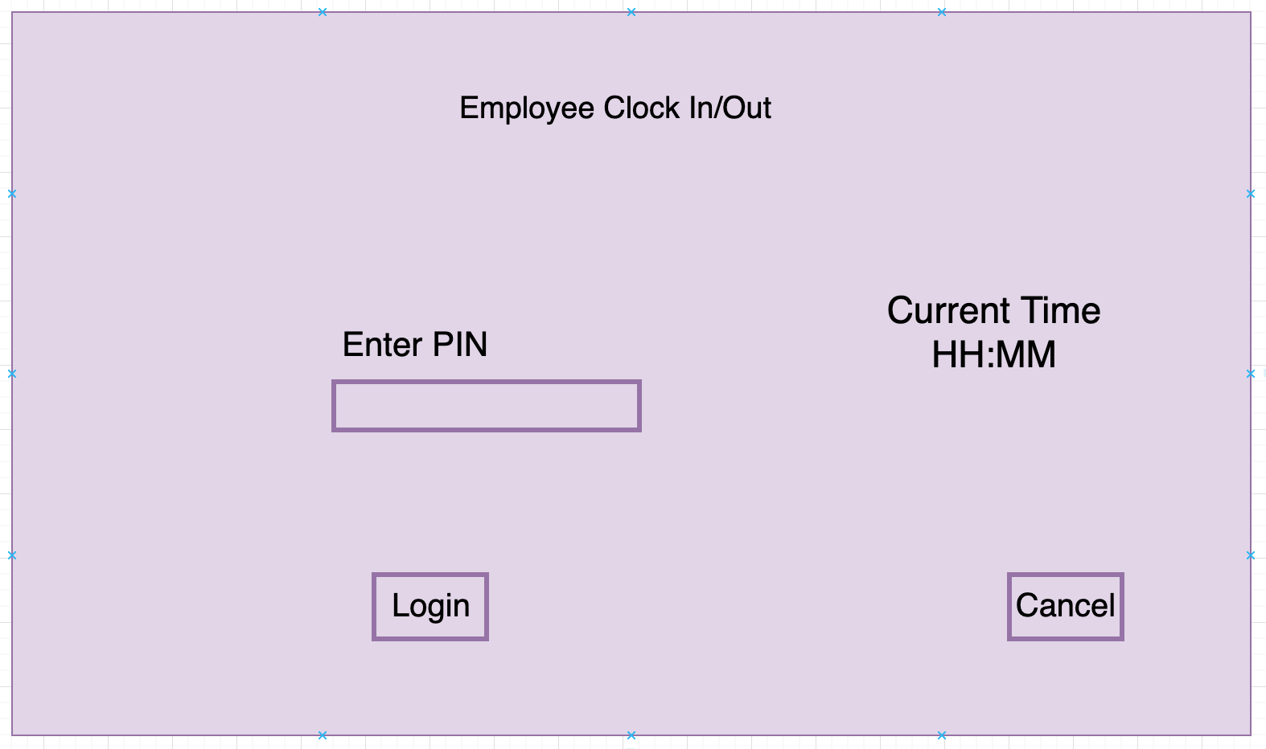

Fig 11: Employee Clock In/out Login UI

Screen 2B

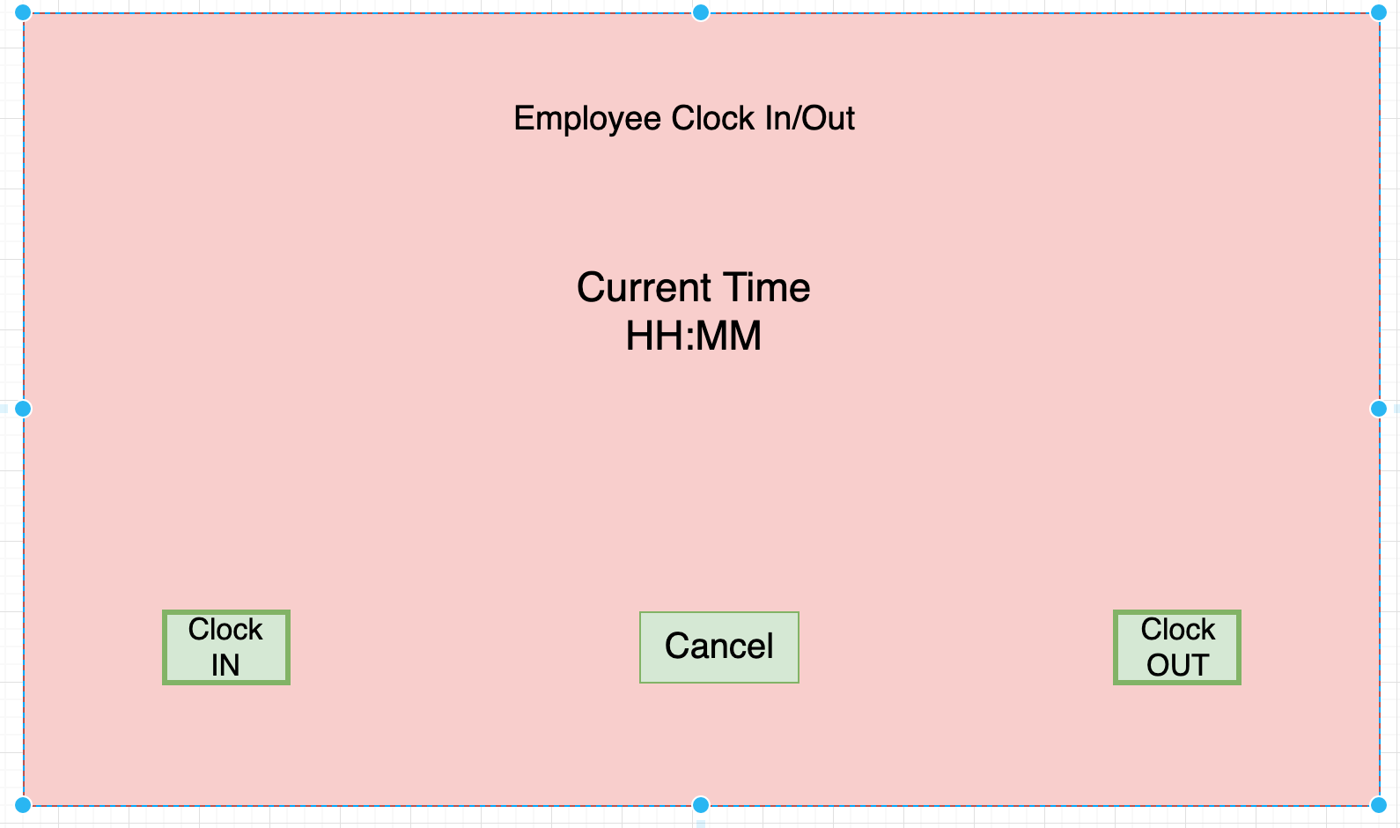

Fig 12: Employee Clock In/Out UI

Figure 11 and 12 shows the employee clock in/out login screen and its functionality screen respectively. On Figure 11, current time in HH:MM format is shown on middle right of screen and in middle left, employee can enter their PIN number to login for accessing Clock In/Out screen. The login button is placed on bottom left which user can use to login to the system after entering their respective PIN. Also, there is a Cancel button on bottom right which allows the user to get to the main Dashboard.

Figure 12 is the main functionality screen of the employee Clock In/Out system. Current time in HH:MM format is shown in the middle of the screen to notify user of the time. The Clock In button is placed on bottom left of the screen which when pressed will record the current time as Time In of the user and display a message that Time In has been recorded successfully. The Clock Out button is placed on bottom right of the screen which when pressed will record the current time as Time Out of the user and display a message that Time Out has been recorded successfully. The Cancel button placed in the bottom middle of the screen will allow user to cancel the functionality screen and return to main dashboard.

Screen 3- Cash Register Screen

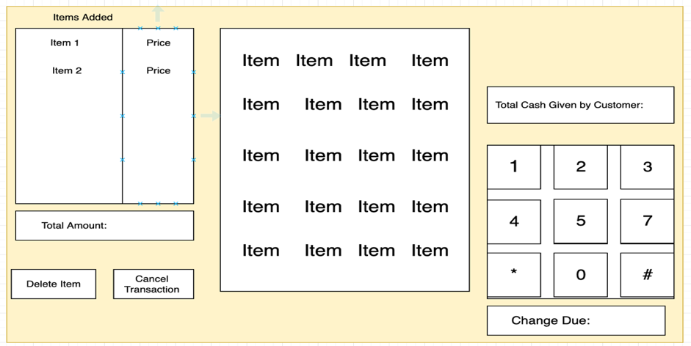

Fig 13: Cash register UI

The Cash register screen is the one of the main functionality screens of the POS system from where user can perform sale transaction. The middle of the screen labeled “Items” shows the available item that can be sold from the system. When one of the items is selected that item and its price is shown in the left side of the screen as shown in the above screen. The total price of all selected item is calculated by the system and shown in the “Total Amount” box. The Delete item button lets the user delete the selected item from transaction whereas the Cancel transaction button on the bottom left of the screen will let the user to cancel the whole transaction. There is a keypad box in the middle right of the screen which is used to enter the total amount of cash given by the customer for the transaction which when entered will be shown on the box above it. the system will then Calculate the change due amount and display it at the bottom right of the screen as shown above.

Screen 4- Administrator Control

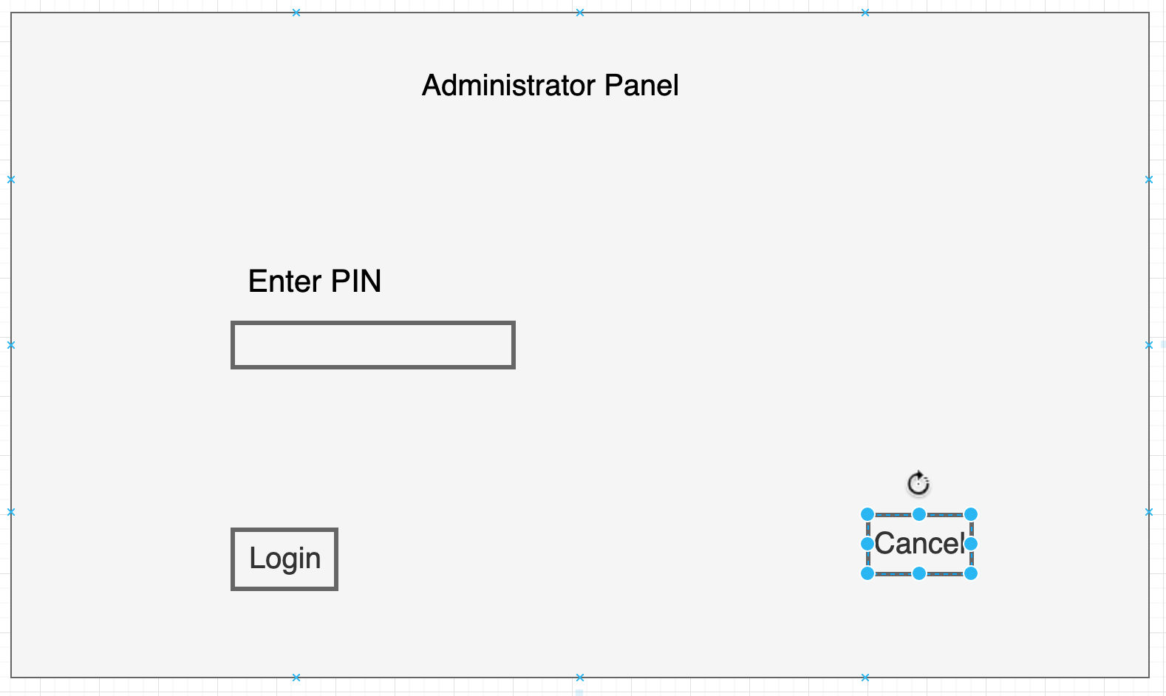

Fig 14: Administrator Panel Login UI

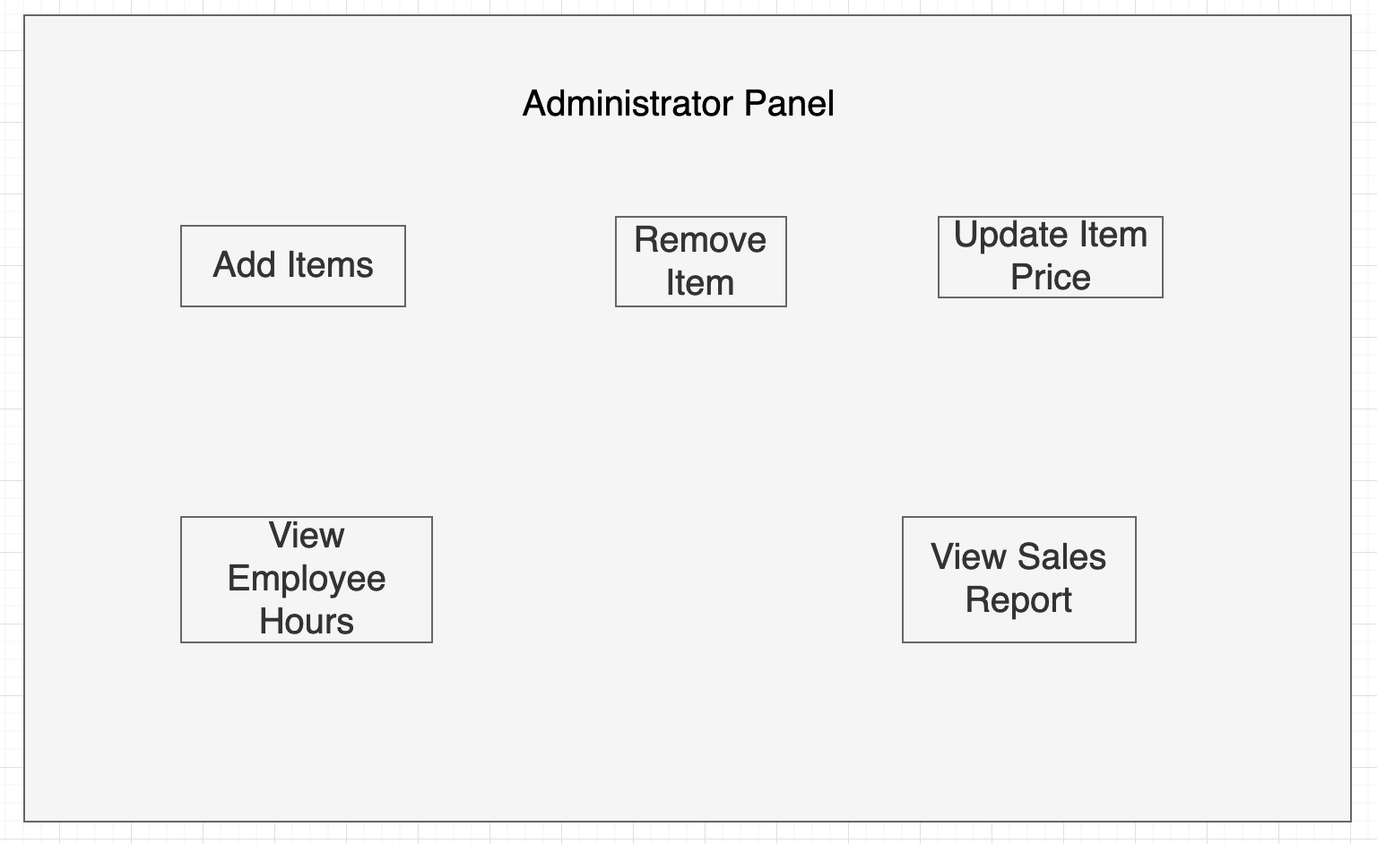

Fig 15: Administrator Panel UI

Figure14 and 15 shows the administrator panel login and its functionality screen respectively.

On figure 14 the administrator can enter their Pin in the middle of the screen and select the login button on the bottom right of the screen to access the administrator control panel. If the PIN is incorrect then an error message is shown to re-enter the pin. The cancel button on the bottom right will let the administrator to return to the main dashboard.

Figure 15 shows the access to the administrator panel and various functionalities that are available in that screen. The add items, remove items and update item price button on the upper left, middle and upper right of the screen to let the admin to add item to the inventory, remove item from the inventory and update the price of the item respectively. The View Employee Hours button on bottom left of the screen will let the admin to see the saved Time In/Out hours of the employee. The View Sales Report button on bottom right will let the admin to see all the sales transaction that has been performed from the cash register screen.

7. Conclusion

The design process was overall a great learning process. This process helped us visualize our actual program and familiarized us with the minor as well as the major aspects of the program. Designing class diagrams, sequence diagrams and state diagrams were very useful for the project as it visually guided us into the program that we are creating. The main thing that we have learnt during the design process is that we should always start out project with the design document. This helps us visualize our overall project and makes the coding part easier with clear concepts. We did not have any particular difficulty during the design process. However, we felt that time is really a big constraint for our project. It took much more time to complete the whole document. We can mitigate this problem in the coding process by working ahead of time and not waiting till the last minute.

References:

<https://ieeeauthorcenter.ieee.org/wp-content/uploads/IEEE-Reference-Guide.pdf>